**24.1. OneToMany - Bi-Directional Overview**

**One-to-Many Mapping**:

* An instructor can have many courses
* Bi-directional

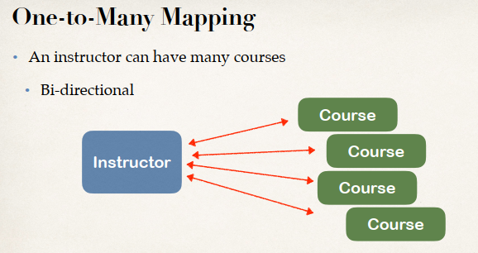

**Many-to-One Mapping**:

* Many courses can have one instructor
* Inverse / opposite of One-to-Many



**Real-World Project Requirement**:

* If we delete an instructor, DO NOT delete the courses
* If we delete a course, DO NOT delete the instructor

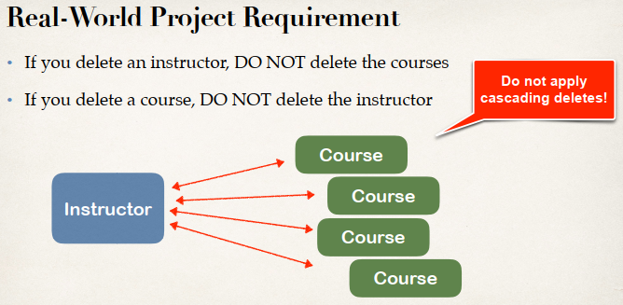

This means don’t apply the “cascade delete”

**Development Process: One-to-Many (Step-by-Step)**:

1. Prep Work - Define database tables
2. Create Course class
3. Update Instructor class
4. Create Main App

**1) Prep Work - Define database tables**:

Run the following SQL script from “hibernate-mapping-database-scripts/hb-03-one-to-many”

**Filename: create-db.sql**:

DROP SCHEMA IF EXISTS `hb-03-one-to-many`;

CREATE SCHEMA `hb-03-one-to-many`;

use `hb-03-one-to-many`;

SET FOREIGN_KEY_CHECKS = 0;

DROP TABLE IF EXISTS `instructor_detail`;

CREATE TABLE `instructor_detail` (

`id` int(11) NOT NULL AUTO_INCREMENT,

`youtube_channel` varchar(128) DEFAULT NULL,

`hobby` varchar(45) DEFAULT NULL,

PRIMARY KEY (`id`)

) ENGINE=InnoDB AUTO_INCREMENT=1 DEFAULT CHARSET=latin1;

DROP TABLE IF EXISTS `instructor`;

CREATE TABLE `instructor` (

`id` int(11) NOT NULL AUTO_INCREMENT,

`first_name` varchar(45) DEFAULT NULL,

`last_name` varchar(45) DEFAULT NULL,

`email` varchar(45) DEFAULT NULL,

`instructor_detail_id` int(11) DEFAULT NULL,

PRIMARY KEY (`id`),

KEY `FK_DETAIL_idx` (`instructor_detail_id`),

CONSTRAINT `FK_DETAIL` FOREIGN KEY (`instructor_detail_id`)

REFERENCES `instructor_detail` (`id`) ON DELETE NO ACTION ON UPDATE NO ACTION

) ENGINE=InnoDB AUTO_INCREMENT=1 DEFAULT CHARSET=latin1;

DROP TABLE IF EXISTS `course`;

CREATE TABLE `course` (

`id` int(11) NOT NULL AUTO_INCREMENT,

`title` varchar(128) DEFAULT NULL,

`instructor_id` int(11) DEFAULT NULL,

PRIMARY KEY (`id`),

UNIQUE KEY `TITLE_UNIQUE` (`title`),

KEY `FK_INSTRUCTOR_idx` (`instructor_id`),

CONSTRAINT `FK_INSTRUCTOR`

FOREIGN KEY (`instructor_id`)

REFERENCES `instructor` (`id`)

ON DELETE NO ACTION ON UPDATE NO ACTION

) ENGINE=InnoDB AUTO_INCREMENT=10 DEFAULT CHARSET=latin1;

SET FOREIGN_KEY_CHECKS = 1;

Here we are creating three tables.

1. instructor
2. instructor_detail
3. course

**Table: instructor**:

CREATE TABLE `instructor_detail` (

`id` int(11) NOT NULL AUTO_INCREMENT,

`youtube_channel` varchar(128) DEFAULT NULL,

`hobby` varchar(45) DEFAULT NULL,

PRIMARY KEY (`id`)

) ENGINE=InnoDB AUTO_INCREMENT=1 DEFAULT CHARSET=latin1;

**Table: instructor_detail**:

CREATE TABLE `instructor` (

`id` int(11) NOT NULL AUTO_INCREMENT,

`first_name` varchar(45) DEFAULT NULL,

`last_name` varchar(45) DEFAULT NULL,

`email` varchar(45) DEFAULT NULL,

`instructor_detail_id` int(11) DEFAULT NULL,

PRIMARY KEY (`id`),

KEY `FK_DETAIL_idx` (`instructor_detail_id`),

CONSTRAINT `FK_DETAIL` FOREIGN KEY (`instructor_detail_id`)

REFERENCES `instructor_detail` (`id`) ON DELETE NO ACTION ON UPDATE NO ACTION

) ENGINE=InnoDB AUTO_INCREMENT=1 DEFAULT CHARSET=latin1;

**Table: course**:

CREATE TABLE `course` (

`id` int(11) NOT NULL AUTO_INCREMENT,

`title` varchar(128) DEFAULT NULL,

`instructor_id` int(11) DEFAULT NULL,

PRIMARY KEY (`id`),

UNIQUE KEY `TITLE_UNIQUE` (`title`),

KEY `FK_INSTRUCTOR_idx` (`instructor_id`),

CONSTRAINT `FK_INSTRUCTOR`

FOREIGN KEY (`instructor_id`)

REFERENCES `instructor` (`id`)

ON DELETE NO ACTION ON UPDATE NO ACTION

) ENGINE=InnoDB AUTO_INCREMENT=10 DEFAULT CHARSET=latin1;

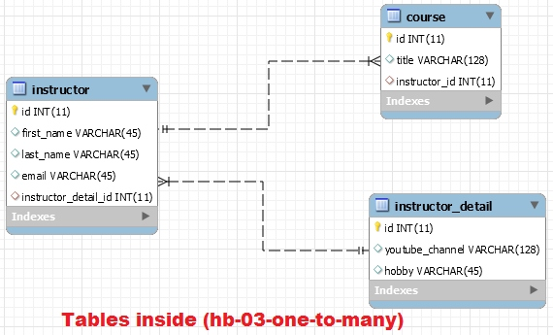

24.1. OneToMany - Bi-Directional Overview